

**GITAM SCHOOL OF BUSINESS**

**Twitter Sentiment Analysis- A NLP Use-Case for Beginners**

**UNDER THE GUIDANCE OF DR. DIVAKAR**

**PROGRAM: BBA-BA**

**YEAR: 2021-2024**

BY:

GURU VENKATA SAI PRASAD MADDILA

**bba business analytics**

**(4TH Semesteer)**

**2022-23**

Introduction

Sentiment analysis refers to identifying as well as classifying the sentiments that are expressed in the text source. Tweets are often useful in generating a vast amount of sentiment data upon analysis. These data are useful in understanding the opinion of the people about a variety of topics.

Therefore, we need to develop an Automated Machine Learning Sentiment Analysis Model in order to compute the customer perception. Due to the presence of non-useful characters (collectively termed as the noise) along with useful data, it becomes difficult to implement models on them.

In this article, we aim to analyse the sentiment of the tweets provided from the Sentiment140 dataset by developing a machine learning pipeline involving the use of three classifiers (Logistic Regression, Bernoulli Naive Bayes, and SVM) along with using Term Frequency- Inverse Document Frequency. The performance of these classifiers is then evaluated using accuracy and F1 Scores.



Table of contents

What is Twitter Sentiment Analysis?

Why is Twitter Sentiment Analysis Important?

How to Do Twitter Sentiment Analysis?

Twitter Sentiment Analysis: Problem Statement

Twitter Sentiment Analysis: Project Pipeline

Step-1: Import the Necessary Dependencies

Step-2: Read and Load the Dataset

Step-3: Exploratory Data Analysis

Step-4: Data Visualization of Target Variables

Step-5: Data Preprocessing

Step-6: Splitting Our Data into Train and Test Subsets

Step-7: Transforming the Dataset Using TF-IDF Vectorizer

Step-8: Function for Model Evaluation

Step-9: Model Building

Step-10: Model Evaluation

Conclusion

What is Twitter Sentiment Analysis?

Twitter sentiment analysis analyses the sentiment or emotion of tweets. It uses natural language processing and machine learning algorithms to classify tweets automatically as positive, negative, or neutral based on their content. It can be done for individual tweets or a larger dataset related to a particular topic or event.

Why is Twitter Sentiment Analysis Important?

1. Understanding Customer Feedback: By analysing the sentiment of customer feedback, companies can identify areas where they need to improve their products or services.
2. Reputation Management: Sentiment analysis can help companies monitor their brand reputation online and quickly respond to negative comments or reviews.
3. Political Analysis: Sentiment analysis can help political campaigns understand public opinion and tailor their messaging accordingly.
4. Crisis Management: In the event of a crisis, sentiment analysis can help organizations monitor social media and news outlets for negative sentiment and respond appropriately.
5. Marketing Research: Sentiment analysis can help marketers understand consumer behaviour and preferences, and develop targeted advertising campaigns.

How to Do Twitter Sentiment Analysis?

In this article, we aim to analyse Twitter sentiment analysis using machine learning algorithms, the sentiment of tweets provided from the Sentiment140 dataset by developing a machine learning pipeline involving the use of three classifiers (Logistic Regression, Bernoulli Naive Bayes, and SVM) along with using Term Frequency- Inverse Document Frequency (TF-IDF). The performance of these classifiers is then evaluated using accuracy and F1 Scores.

Twitter Sentiment Analysis: Problem Statement

In this project, we try to implement an NLP Twitter sentiment analysis model that helps to overcome the challenges of sentiment classification of tweets. We will be classifying the tweets into positive or negative sentiments. The necessary details regarding the dataset involving the Twitter sentiment analysis project are:

The dataset provided is the Sentiment140 Dataset which consists of 1,600,000 tweets that have been extracted using the Twitter API. The various columns present in this Twitter data are:

target: the polarity of the tweet (positive or negative)

ids: Unique id of the tweet

date: the date of the tweet

flag: It refers to the query. If no such query exists, then it is NO QUERY.

user: It refers to the name of the user that tweeted

text: It refers to the text of the tweet.

Project Pipeline

The various steps involved in the Machine Learning Pipelines are :

* Import Necessary Dependencies
* Read and Load the Dataset
* Exploratory Data Analysis
* Data Visualization of Target Variables
* Data Preprocessing
* Splitting our data into Train and Test Subset
* Transforming Dataset using TF-IDF Vectorizer
* Function for Model Evaluation
* Model Building
* Conclusion

Step-1: Import the Necessary Dependencies

# utilities

**import** re

**import** numpy **as** np

**import** pandas **as** pd

# plotting

**from** wordcloud **import** WordCloud

**import** matplotlib.pyplot **as** plt

# nltk

**from** nltk.stem **import** WordNetLemmatizer

# sklearn

**from** sklearn.svm **import** LinearSVC

**from** sklearn.naive_bayes **import** BernoulliNB

**from** sklearn.linear_model **import** LogisticRegression

**from** sklearn.model_selection **import** train_test_split

**from** sklearn.feature_extraction.text **import** TfidfVectorizer

**from** sklearn.metrics **import** confusion_matrix, classification_report

Step-2: Read and Load the Dataset

# Importing the dataset

DATASET_COLUMNS=['target','ids','date','flag','user','text']

DATASET_ENCODING = "ISO-8859-1"

df = pd.read_csv('Project_Data.csv', encoding=DATASET_ENCODING, names=DATASET_COLUMNS)

df.sample(5)

Output:

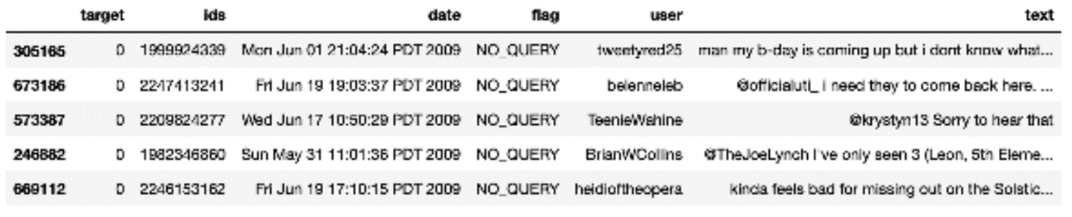

Step-3: Exploratory Data Analysis

3.1: Five top records of data

df.head()

Output:

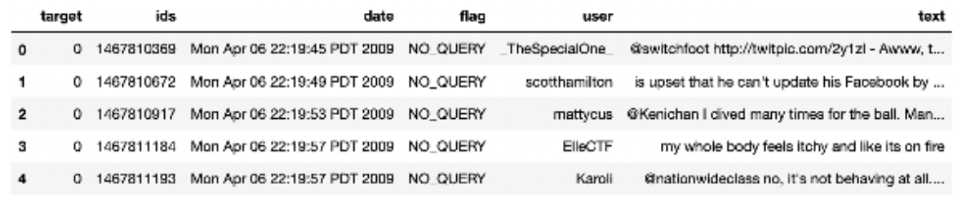

3.2: Columns/features in data

df.columns

Output:

Index(['target', 'ids', 'date', 'flag', 'user', 'text'], dtype='object')

3.3: Length of the dataset

print('length of data is', len(df))

Output:

length of **data** **is** 1048576

3.4: Shape of data

df. Shape

Output:

(1048576, 6)

3.5: Data information

df.info()

Output:

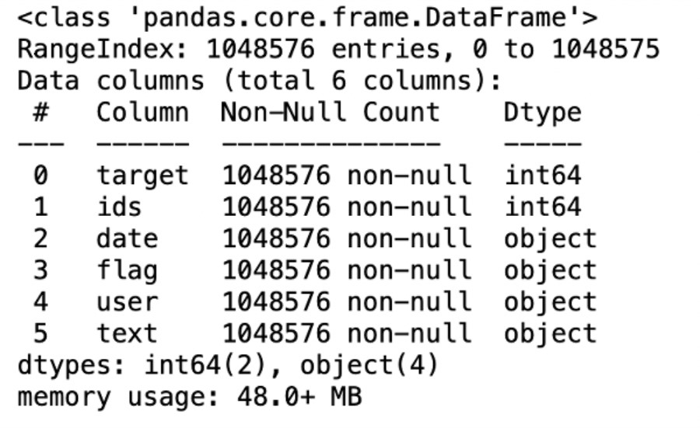

3.6: Datatypes of all columns

df.dtypes

Output:

target int64

ids int64

date object

flag object

user object

**text** object

dtype: object

3.7: Checking for null values

**np**.sum(df.isnull().any(axis=1))

Output:

0

3.8: Rows and columns in the dataset

print('Count of columns in the data is: ', len(df.columns))

print('Count of rows in the data is: ', len(df))

Output:

Count of columns **in** the **data** **is**: 6

Count of rows **in** the **data** **is**: 1048576

3.9: Check unique target values

df['target'].unique()

Output:

array([0, 4], dtype=int64)

3.10: Check the number of target values

df['target'].nunique()

Output:

2

Step-4: Data Visualization of Target Variables

# Plotting the distribution for dataset.

ax = df.groupby('target').count().plot(kind='bar', title='Distribution of data',legend=False)

ax.set_xticklabels(['Negative','Positive'], rotation=0)

# Storing data in lists.

text, sentiment = list(df['text']), list(df['target'])

Output:

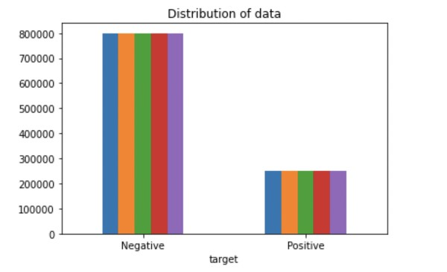

**import** seaborn **as** sns

sns.countplot(x='target', **data**=df)

Output:

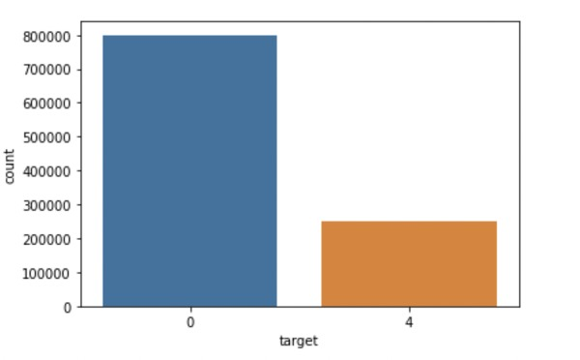

Step-5: Data Preprocessing

In the above-given problem statement, before training the model, we performed various pre-processing steps on the dataset that mainly dealt with removing stop words, removing special characters like emojis, hashtags, etc. The text document is then converted into lowercase for better generalization.

Subsequently, the punctuations were cleaned and removed, thereby reducing the unnecessary noise from the dataset. After that, we also removed the repeating characters from the words along with removing the URLs as they do not have any significant importance.

At last, we then performed Stemming (reducing the words to their derived stems) and Lemmatization (reducing the derived words to their root form, known as lemma) for better results.

5.1: Selecting the text and Target column for our further analysis

data=df[['text','target']]

5.2: Replacing the values to ease understanding.

**data**['target'] = **data**['target'].replace(4,1)

5.3: Printing unique values of target variables

data['target'].unique()

**Output:**

array([0, 1], dtype=int64)

5.4: Separating positive and negative tweets

data_pos = data[data['target'] == 1]

data_neg = data[data['target'] == 0]

5.5: Taking one-fourth of the data so we can run it on our machine easily

data_pos = data_pos.iloc[:int(20000)]

data_neg = data_neg.iloc[:int(20000)]

5.6: Combining positive and negative tweets

dataset = pd.concat([data_pos, data_neg])

5.7: Making statement text in lowercase

dataset['text']=dataset['text'].str.lower()

dataset['text'].tail()

Output:

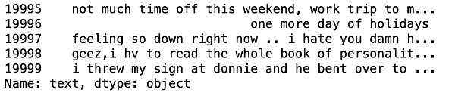

5.8: Defining set containing all stop words in English

stopwordlist = ['a', 'about', 'above', 'after', 'again', 'ain', 'all', 'am', 'an',

'and','any','are', 'as', 'at', 'be', 'because', 'been', 'before',

'being', 'below', 'between','both', 'by', 'can', 'd', 'did', 'do',

'does', 'doing', 'down', 'during', 'each','few', 'for', 'from',

'further', 'had', 'has', 'have', 'having', 'he', 'her', 'here',

'hers', 'herself', 'him', 'himself', 'his', 'how', 'i', 'if', 'in',

'into','is', 'it', 'its', 'itself', 'just', 'll', 'm', 'ma',

'me', 'more', 'most','my', 'myself', 'now', 'o', 'of', 'on', 'once',

'only', 'or', 'other', 'our', 'ours','ourselves', 'out', 'own', 're','s', 'same', 'she', "shes", 'should', "shouldve",'so', 'some', 'such',

't', 'than', 'that', "thatll", 'the', 'their', 'theirs', 'them',

'themselves', 'then', 'there', 'these', 'they', 'this', 'those',

'through', 'to', 'too','under', 'until', 'up', 've', 'very', 'was',

'we', 'were', 'what', 'when', 'where','which','while', 'who', 'whom',

'why', 'will', 'with', 'won', 'y', 'you', "youd","youll", "youre",

"youve", 'your', 'yours', 'yourself', 'yourselves']

5.9: Cleaning and removing the above stop words list from the tweet text

STOPWORDS = set(stopwordlist)

**def** **cleaning_stopwords**(text):

**return** " ".join([word **for** word **in** str(text).split() **if** word **not** **in** STOPWORDS])

dataset['text'] = dataset['text'].apply(**lambda** text: cleaning_stopwords(text))

dataset['text'].head()

Output:

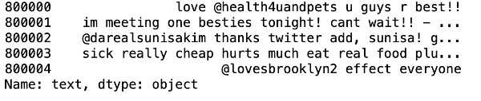

5.10: Cleaning and removing punctuations

**import** string

english_punctuations = string.punctuation

punctuations_list = english_punctuations

**def** **cleaning_punctuations**(text):

translator = str.maketrans('', '', punctuations_list)

**return** text.translate(translator)

dataset['text']= dataset['text'].apply(**lambda** x: cleaning_punctuations(x))

dataset['text'].tail()

Output:

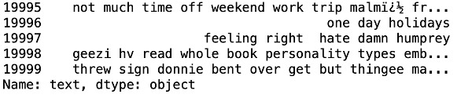

5.11: Cleaning and removing repeating characters

**def** **cleaning_repeating_char**(text):

**return** re.sub(r'(.)1+', r'1', text)

dataset['text'] = dataset['text'].apply(**lambda** x: cleaning_repeating_char(x))

dataset['text'].tail()

**Output:**

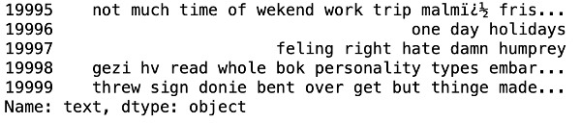

5.12: Cleaning and removing URLs

def cleaning_URLs(data):

return re.sub('((www.[^s]+)|(https?://[^s]+))',' ',data)

dataset['text'] = dataset['text'].apply(lambda x: cleaning_URLs(x))

dataset['text'].tail()

Output:



5.13: Cleaning and removing numeric numbers

def cleaning_numbers(data):

return re.sub('[0-9]+', '', data)

dataset['text'] = dataset['text'].apply(lambda x: cleaning_numbers(x))

dataset['text'].tail()

Output:

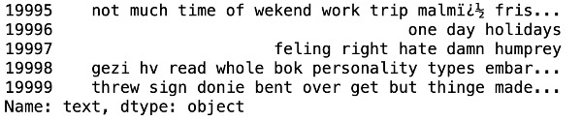

5.14: Getting tokenization of tweet text

**from** nltk.tokenize **import** RegexpTokenizer

tokenizer = RegexpTokenizer(r'w+')

dataset['text'] = dataset['text'].apply(tokenizer.tokenize)

dataset['text'].head()

Output:

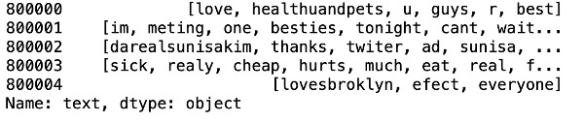

5.15: Applying stemming

**import** nltk

st = nltk.PorterStemmer()

def stemming_on_text(**data**):

text = [st.stem(word) **for** word **in** **data**]

**return** **data**

dataset['text']= dataset['text'].apply(lambda x: stemming_on_text(x))

dataset['text'].head()

Output:

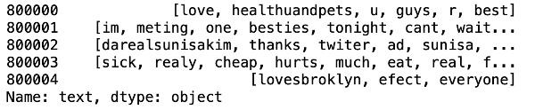

5.16: Applying lemmatizer

lm = nltk.WordNetLemmatizer()

def lemmatizer_on_text(**data**):

text = [lm.lemmatize(word) **for** word **in** **data**]

**return** **data**

dataset['text'] = dataset['text'].apply(lambda x: lemmatizer_on_text(x))

dataset['text'].head()

Output:

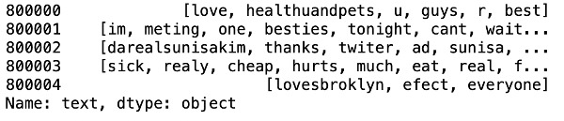

5.17: Separating input feature and label

X=data.text

y=data.target

5.18: Plot a cloud of words for negative tweets

data_neg = data['text'][:800000]

plt.figure(figsize = (20,20))

wc = WordCloud(max_words = 1000 , width = 1600 , height = 800,

collocations=False).generate(" ".join(data_neg))

plt.imshow(wc)

**Output:**

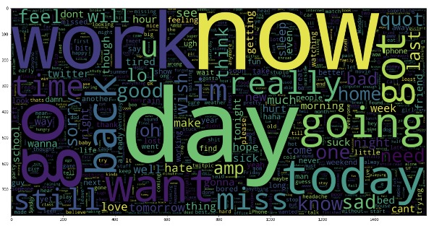

5.19: Plot a cloud of words for positive tweets

data_pos = data['text'][800000:]

wc = WordCloud(max_words = 1000 , width = 1600 , height = 800,

collocations=False).generate(" ".join(data_pos))

plt.figure(figsize = (20,20))

plt.imshow(wc)

Output:

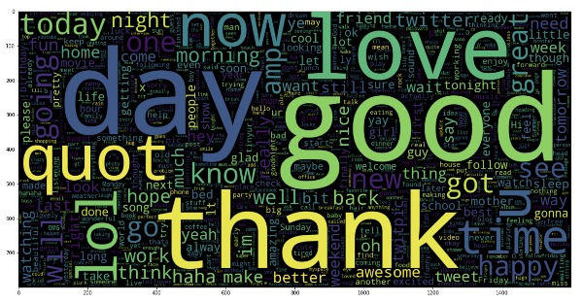

Step-6: Splitting Our Data Into Train and Test Subsets

# Separating the 95% **data** **for** training **data** and 5% **for** testing **data**

X_train, X_test, y_train, y_test = train_test_split(X,y,test_size = 0.05, random_state =26105116

Step-7: Transforming the Dataset Using TF-IDF Vectorizer

7.1: Fit the TF-IDF Vectorizer

vectoriser = TfidfVectorizer(ngram_range=(1,2), max_features=500000)

vectoriser.fit(X_train)

print('No. of feature_words: ', len(vectoriser.get_feature_names()))

**Output:**

No. of feature_words: 500000

7.2: Transform the data using TF-IDF Vectorizer

X_train = vectoriser.transform(X_train)

X_test = vectoriser.transform(X_test)

Step-8: Function for Model Evaluation

After training the model, we then apply the evaluation measures to check how the model is performing. Accordingly, we use the following evaluation parameters to check the performance of the models respectively:

Accuracy Score

Confusion Matrix with Plot

ROC-AUC Curve

**def** **model_Evaluate**(model):

# Predict values for Test dataset

y_pred = model.predict(X_test)

# Print the evaluation metrics for the dataset.

print(classification_report(y_test, y_pred))

# Compute and plot the Confusion matrix

cf_matrix = confusion_matrix(y_test, y_pred)

categories = ['Negative','Positive']

group_names = ['True Neg','False Pos', 'False Neg','True Pos']

group_percentages = ['{0:.2%}'.format(value) **for** value **in** cf_matrix.flatten() / np.sum(cf_matrix)]

labels = [f'{v1}n{v2}' **for** v1, v2 **in** zip(group_names,group_percentages)]

labels = np.asarray(labels).reshape(2,2)

sns.heatmap(cf_matrix, annot = labels, cmap = 'Blues',fmt = '',

xticklabels = categories, yticklabels = categories)

plt.xlabel("Predicted values", fontdict = {'size':14}, labelpad = 10)

plt.ylabel("Actual values" , fontdict = {'size':14}, labelpad = 10)

plt.title ("Confusion Matrix", fontdict = {'size':18}, pad = 20)

Step-9: Model Building

In the problem statement, we have used three different models respectively :

Bernoulli Naive Bayes Classifier

SVM (Support Vector Machine)

Logistic Regression

The idea behind choosing these models is that we want to try all the classifiers on the dataset ranging from simple ones to complex models, and then try to find out the one which gives the best performance among them.

8.1: Model-1

BNBmodel = BernoulliNB()

BNBmodel.fit(X_train, y_train)

model_Evaluate(BNBmodel)

y_pred1 = BNBmodel.predict(X_test)

Output:

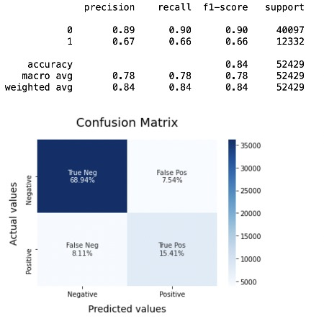

8.2: Plot the ROC-AUC Curve for model-1

**from** sklearn.metrics **import** roc_curve, auc

fpr, tpr, thresholds = **roc_curve**(y_test, y_pred1)

roc_auc = **auc**(fpr, tpr)

plt.**figure**()

plt.**plot**(fpr, tpr, color='darkorange', lw=1, label='ROC curve (area = %0.2f)' % roc_auc)

plt.**xlim**([0.0, 1.0])

plt.**ylim**([0.0, 1.05])

plt.**xlabel**('False Positive Rate')

plt.**ylabel**('True Positive Rate')

plt.**title**('ROC CURVE')

plt.**legend**(loc="lower right")

plt.**show**()

Output:

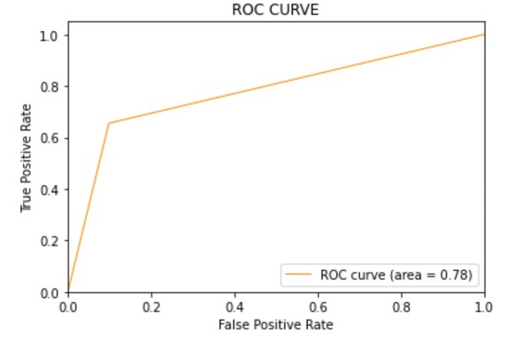

8.3: Model-2:

SVCmodel = LinearSVC()

SVCmodel.fit(X_train, y_train)

model_Evaluate(SVCmodel)

y_pred2 = SVCmodel.predict(X_test)

Output:

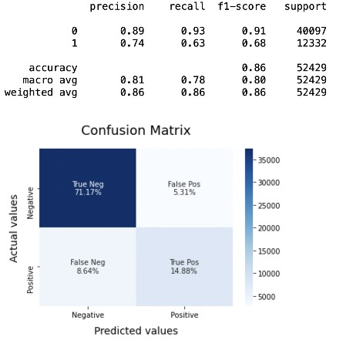

8.4: Plot the ROC-AUC Curve for model-2

**from** sklearn.metrics **import** roc_curve, auc

fpr, tpr, thresholds = **roc_curve**(y_test, y_pred2)

roc_auc = **auc**(fpr, tpr)

plt.**figure**()

plt.**plot**(fpr, tpr, color='darkorange', lw=1, label='ROC curve (area = %0.2f)' % roc_auc)

plt.**xlim**([0.0, 1.0])

plt.**ylim**([0.0, 1.05])

plt.**xlabel**('False Positive Rate')

plt.**ylabel**('True Positive Rate')

plt.**title**('ROC CURVE')

plt.**legend**(loc="lower right")

plt.**show**()

Output:

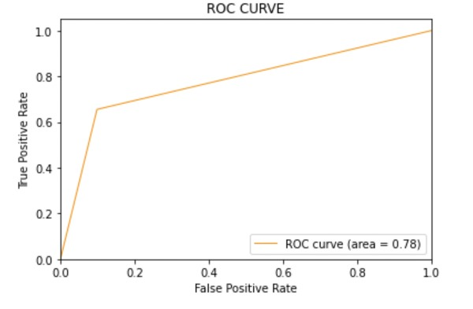

8.5: Model-3

LRmodel = LogisticRegression(C = 2, max_iter = 1000, n_jobs=-1)

LRmodel.fit(X_train, y_train)

model_Evaluate(LRmodel)

y_pred3 = LRmodel.predict(X_test)

Output:

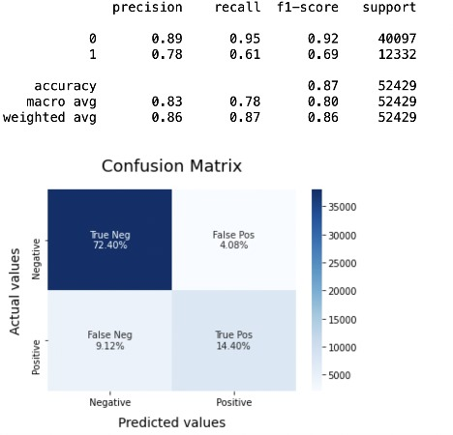

8.6: Plot the ROC-AUC Curve for model-3

**from** sklearn.metrics **import** roc_curve, auc

fpr, tpr, thresholds = **roc_curve**(y_test, y_pred3)

roc_auc = **auc**(fpr, tpr)

plt.**figure**()

plt.**plot**(fpr, tpr, color='darkorange', lw=1, label='ROC curve (area = %0.2f)' % roc_auc)

plt.**xlim**([0.0, 1.0])

plt.**ylim**([0.0, 1.05])

plt.**xlabel**('False Positive Rate')

plt.**ylabel**('True Positive Rate')

plt.**title**('ROC CURVE')

plt.**legend**(loc="lower right")

plt.**show**()

Output:



Step-10: Model Evaluation

Accuracy: As far as the accuracy of the model is concerned, Logistic Regression performs better than SVM, which in turn performs better than Bernoulli Naive Bayes.

F1-score: The F1 Scores for class 0 and class 1 are :

(a) For class 0: Bernoulli Naive Bayes(accuracy = 0.90) < SVM (accuracy =0.91) < Logistic Regression (accuracy = 0.92)

(b) For class 1: Bernoulli Naive Bayes (accuracy = 0.66) < SVM (accuracy = 0.68) < Logistic Regression (accuracy = 0.69)

AUC Score: All three models have the same ROC-AUC score.

We, therefore, conclude that the Logistic Regression is the best model for the above-given dataset.

In our problem statement, Logistic Regression follows the principle of Occam’s Razor, which defines that for a particular problem statement, if the data has no assumption, then the simplest model works the best. Since our dataset does not have any assumptions and Logistic Regression is a simple model. Therefore, the concept holds true for the above-mentioned dataset.

Conclusion

We hope through this article, you got a basic of how Sentimental Analysis is used to understand public emotions behind people’s tweets. As you’ve read in this article, Twitter Sentimental Analysis helps us preprocess the data (tweets) using different methods and feed it into ML models to give the best accuracy.

* Twitter Sentimental Analysis is used to identify as well as classify the sentiments that are expressed in the text source.
* Logistic Regression, SVM, and Naive Bayes are some of the ML algorithms that can be used for Twitter Sentimental Analysis.